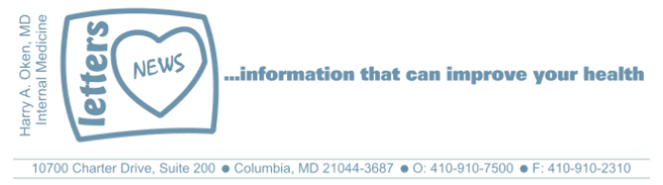
COVID-19-123, April 1, 2025
Dear Patients:

Friendship is a cornerstone of a fulfilling life. A good friend provides a blend of support, joy and connection. A friend is a safe haven to be your authentic self without being jaded. Friends celebrate triumphs and provide comfort for our struggles.

I am so fortunate to have a lot of close friends, and I am grateful for these people who have added to my life and supported my well-being. Supportive family and friendships are potent anti-aging interventions because they create happiness and combat stress. Stress is the most significant factor that tips our immune system and makes us more vulnerable to aging and illness.

With my close friends, our lives have different friendship chapters: grade school, college, medical school, residency, and practice. The trick is cultivating these friendships to keep them as close friends. I strive to continue to connect with my close friends; I am not always perfect at it, but I practice friendship. It is not unusual for me to call someone I have not spoken to for a while and reconnect.

It is easy to take friendships for granted; it's also easy to underestimate the best friend in your spouse, often your biggest supporter, confidant, and the person who may know you best. Just recently, a patient said to me, in regard to an upcoming procedure, that her husband told her that as we age, we are both going to have health challenges. "I am there for you, and you are there for me; we have each other".

Celebrate and embrace your friends; they are a healthy tonic for what ails you!

It may be as simple as this: "My friends are my estate" -Emily Dickinson.

Medical Update on Measles:

- The measles vaccine (MMR) is highly effective, providing lifelong protection.
- If you were born before 1957, you are up to date because you most likely have natural immunity.
- If you were born between 1957 and 1962, you were most likely given two doses of the MMR vaccine and are therefore up to date.
- If you were born between 1963 and 1967, you may have received a different vaccine (inactivated) that was less effective. If you are concerned, we can check your measles titer; however, I am not concerned about a lack of immunity.
- If you were born in 1968 or later, you were most likely given two doses of the MMR vaccine and are therefore up to date.
- No vaccine is 100% effective, but breakthrough cases are rare, and those cases are typically mild.
- If you decide you want your titer checked, please call my office to arrange a blood draw.

-------------------------------------------------------------------------------------------------------------------------------------
On a musical note: For Good from the Wicked Original Broadway Cast Recording

For Good is one of the most iconic songs from Wicked. It stands as an anthem for forgiveness and also gratitude for the ways that other people can influence us and change our lives.

These lyrics from the song particularly resonate with me:

Who can say if I've been changed for the better?
I do believe I've been changed for the better.
Because I knew you
I have been changed,
For good.


-------------------------------------------------------------------------------------------------------------------------------------
-------------------------------------------------------------------------------------------------------------------------------------
On a lighter note:

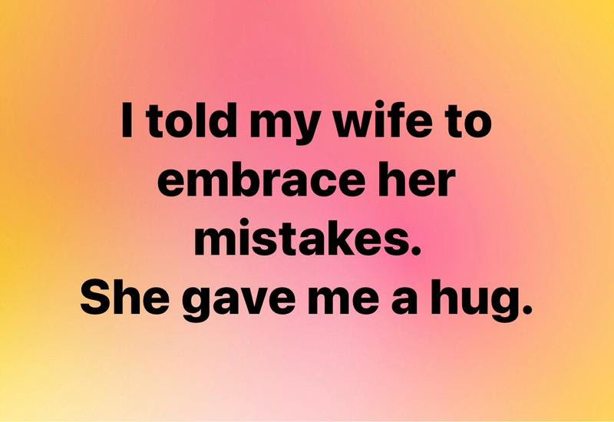

-------------------------------------------------------------------------------------------------------------------------------------

As a reminder, I no longer send daily updates; instead, I will update you periodically. I continue to enjoy writing these updates. Initially, these were only sent to my patients; however, I've been humbled to learn that, through social media, these writings have been forwarded and re-forwarded to many. I have found great joy in knowing that this simple act of sharing facts, thoughts, opinions, and hopes has touched you in some way. Hopefully I've been able to reassure you, maybe make you smile and laugh, soothe your worries, and comfort you. And maybe, just maybe, I've helped you to be in the moment!

HAO

Harry Oken MD
Former Chairman of Medicine 1994-2008
Howard County General Hospital

View previous newsletters: http://harryokenmd.com/COVID-19-HOME.htm.

Links for Today

For Good from the Wicked Original Broadway Cast Recording
https://www.youtube.com/watch?v=wYTeyNB1k5g&list=RDwYTeyNB1k5g&start_radio=1

