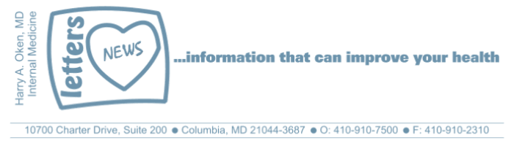

Labor Day – September 2013

Influenza Vaccination 2013-2014
The first order of business is to let you know we have received our influenza vaccine for the 2013-2014 season. Please feel free to stop by (no appointment needed) for your vaccination, Monday - Friday between 8:30 AM and noon. Alternatively, we are happy to give the vaccination at an upcoming visit.
I do advise you to try and get your vaccine before the end of the year. Influenza is the name of the virus that causes the flu. The virus is quite infectious to those without adequate immunity. Consider this fact as a good reason to get the vaccine: a person who is incubating the flu will actively be shedding the virus to others for 24 hours prior to showing symptoms of the flu. This literally makes them a "Typhoid Mary," infecting others who are not immune.
If you would like more information about the flu vaccine, please see my Columbia Matters video at the link below:
http://www.columbiamatters.org/_files/videos/2010/November/CM1110_oken.html
Vitamin D
As many of you know, there are some supplements that I recommend to enhance your health. Vitamin D-3, 1000 units per day, is one that I routinely recommend. It helps facilitate improved absorption of calcium from your diet. It seems to enhance our immune system by decreasing our likelihood of developing cancer and certain viral infections, namely influenza. It is quite interesting that influenza is a problem during the months of the year that there is less sunlight, particularly in temperate zones and less likely in the tropics. Fifteen minutes of direct sunlight per day also increases your Vitamin D levels. The sunlight causes conversion of inactive Vitamin D to an active form.

If you are not currently taking Vitamin D, consider adding it to your daily regimen. All of my recommendations are based on my research of peer reviewed evidence from information published in the medical literature. In addition to the link below, you may also find more information on Vitamin D in the attachment.
http://ajcn.nutrition.org/content/early/2010/03/10/ajcn.2009.29094.abstract
Controlling Stress
Wouldn't it be nice to be imperturbable? What I mean by that is to not allow stress to make your mind imagine bad outcomes and catapult you to worry and fear. Stress and worry elevate our cortisol levels and catecholamines (adrenaline) which affect our cardiovascular and immune systems.
Learning to become imperturbable is a process that gets easier with age. And, as we age, our brain changes and life issues that may have upset us in the past, often do not any longer. That change in thinking and processing is often referred to as wisdom. We learn from our past failures and really get what we create. And as we age, our funny quirks usually get worse, so we must be tolerant of our elders!
Remember that anxious thoughts are just that - thoughts. And thoughts are chemical messages in your mind. You control your thoughts and your thoughts control your emotions. A powerful mind can make you feel bad. That same powerful mind can learn to create positive thoughts that can cause you to feel content, happy and optimistic.
If you find yourself with lots of stress, perhaps these simple ideas below will help you become more imperturbable, in other words, not allow events and issues that occur to take you to a dark place of doom and gloom.
Control things that you can control.
Proactively work towards what you want to happen; avoid worrying about what you cannot control and bad outcomes. This means entering the field of positive intention. Intend on creating the outcome you want. Have contingency plans for potholes, but focus on what you want to happen, NOT what you do not want to happen.
Get your exercise, enjoy good nutrition and restful sleep, and avoid excessive alcohol. Distract yourself with pleasurable activities; spend time with the people you love - your family and friends. Be grateful for all you have.
Enjoy your pets!
Speaking of pets, I want to tell you about our 2 rescued Old English Sheepdogs. Cutha is a healthy 80 pound female who is 13 years old. She acts much younger and constantly barks for attention. Silver is an almost 10 year old, 70 pound male with lots of health problems, yet manageable.
Silver has very severe lower spine arthritis. He recently got over a prolonged respiratory infection followed by acute loss of sight (sudden acute retinal deterioration). The treatment prescribed for loss of sight, high dose prednisone, gave him steroid side effects but no change to his vision, so we rapidly tapered them. His lower spine arthritis made him less ambulatory and surgery was not an option. Between his sudden loss of vision and low back pain he was really having problems. Thank you to Cindy; she shared her success with animal acupuncture, so I investigated it as a treatment for Silver.
Unlike people, animals do not know that sticking needles in key points may make them better. And so we are quite happy that Silver is doing better and back to climbing the steps at bedtime with our help and his harness. Interestingly, his sight has returned - a spontaneous improvement that I can't attribute to the acupuncture. Nevertheless, an additional thank you to our acupuncturist, Beth Grubb, for helping Silver. Acupuncture can be an effective modality for pain relief, stress, irritable bowel, migraines etc.
HAO
Harry A. Oken, MD
…more on Vitamin D

Enjoy this picture of our dogs, Cutha and Silver:
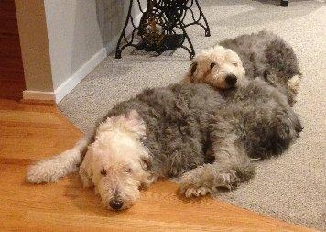 | And thanks to Joe for the email below:  Inner Peace  If you can start the day without caffeine,  If you can always be cheerful, ignoring aches and pains,  If you can resist complaining and boring people with your troubles,  If you can eat the same food every day and be grateful for it,  If you can understand when your loved ones  are too busy to give you any time,  If you can take criticism and blame without resentment,  If you can conquer tension without medical help,  If you can relax without alcohol,  If you can sleep without the aid of drugs,
Then you are probably the family dog!
Handle every stressful situation like a dog.
If you can't eat it or play with it,
Pee on it and walk away.

