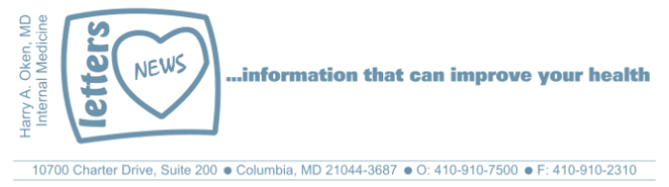
COVID-19-14 – March 27, 2020
Dear Patients,
Start with this --click (thanks JF)

Administrative:
Well...you guessed it. The office will remain closed for the upcoming week. For me, I am just not a desk job guy. I like seeing and interacting with patients face-to-face every day. Clinical medicine is my passion and I miss not seeing you all in person. Have no fear, I am still available virtually 24/7.
The numbers:
US: 85,996 cases 1,200 deaths 1.51% fatality rate (no change from yesterday!)
South Korea: 9,332 cases 139 deaths 1.49% fatality rate (slight increase from yesterday)
Germany: 47,278 cases 281 deaths 0.59% fatality rate (stable)

Maryland: 774 cases 4 deaths 0.6% fatality rate (stable)

The new national focus is to contain the hot spots. New York City (NYC) is a forest fire. Not every tree will burn and remember that 80% of those infected will have a mild illness, but they are vectors for future spread to vulnerable people. Mitigation means sheltering in place and social distancing with excellent hygiene. NYC is the perfect storm: population density, shared transportation modalities, people shoulder to shoulder. Then add the fact that people from all over the world come to NYC and then they leave with the viral passenger. It appears that next up is New Orleans and portions of Florida.

Why NYC is the epicenter of the American coronavirus outbreak:
https://www.cnn.com/2020/03/26/us/new-york-coronavirus-explainer/index.html

Today, the national fatality rate remains unchanged. Understand that the number of cases will rise. Yesterday it was announced that we have tested over 1/2 million people and the positive rate is 14%. This means that 86% of tested people are negative. Presently, 1 out of 5 people tested will be positive; those who test negative who display symptoms perhaps are due to other types of infections (flu, common cold, allergies, or even COVID-19 anxiety).

Hospital activity:
Locally, I was in touch with the hospital yesterday and our activity remains low. The worry is that we will see a spike of activity in 10-14 days. We can be the hero, the power of one. Stay home, frequent hand washing, social distancing. These are our weapons and this is war!

I learned yesterday from another physician who spoke to his friend, a physician in Berkeley, that their ER and hospital activity are both low. The San Francisco Bay Area was shut down in a very proactive fashion much earlier than most areas. Mitigation works!

Science and Therapeutics:
- The Columbia/Oz trial: it is a combination of a good clinical ideas and the scientific methods to look for a remedy! Many hospitals are employing this tactic while we are awaiting results of this trial.
- An encouraging report yesterday is that the virus remains relatively stable, suggesting that it is not mutating. This means that if you have had COVID-19, even mildly, you may have immunity against a re-infection. A test may be available soon to determine if one has been exposed and hence, immunity.
- The use of passive immunity to fight sick patients using blood (actually serum) donated from recovered patients is being used in NYC.
- Still looking for a partner to hand-off information that my group has developed a potential disease-modifying treatment for those infected who are transitioning from mild to severe respiratory insufficiency. Thank you, CB, for working to get your boss, the Senator, involved!
Again, a STILL very important message: avoid Advil (ibuprofen) and Aleve (naproxen) for any reason until we know more about a possible connection to making a COVID-19 infection worse. Use Tylenol (acetaminophen) only!  And on a lighter note to make you smile: (thank you RR)  Stay put, the power of one, be well--  HAO  24/7  Feel free to forward this on: spread the word, not the virus.  To view my previous COVID newsletter updates, go to:  http://harryokenmd.com/COVID-19-HOME.htm  (thank you immensely FS!) | 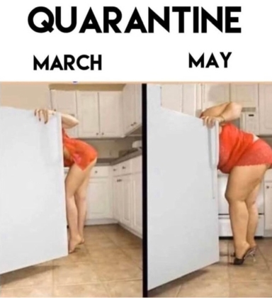
Harry A. Oken, M.D.

Office: 410-910-7500, Fax: 410-910-2310
Cell: 443-324-0823
Adjunct Professor of Medicine
University of Maryland School of Medicine

Video of the Day
What the World needs now is love.
https://www.abccolumbia.com/2020/03/25/students-make-virtual-orchestra-and-sing-what-the-world-needs-now-is-love/

