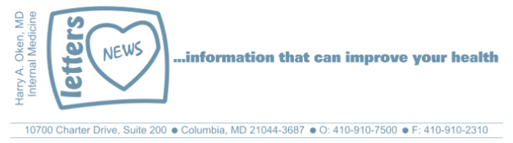
COVID-19-15 – March 28, 2020
Dear Patients,

Today, with dark skies, you may have been waking up (Rise Up video) thinking: another day of worry, anxiety, concern and sadness. I am asking you to remind yourself this is a war the likes of which we have never been challenged to. Yet, because we are a resilient, tough nation, we will rise up. We are resourceful, determined, innovative people who are rising up. And this will pass and we will find silver-lined clouds in the not too distant future. We will prevail.

The numbers:
US: 104,837 cases 1,711 deaths 1.63% fatality rate
South Korea: 9,478 cases 144 deaths 1.5% fatality rate
Germany: 53,340 cases 395 deaths 0.74% fatality rate

Maryland: 992 cases 5 deaths 0.5% fatality rate

As we test more, the number of cases will continue to go up. Our death rate remains low for now.

Here are some things to put in perspective: Maryland has a population of 6 million people. The island of Manhattan is 34 square miles and has 8 million people (23,000 people per square mile). The New York metro area has 20 million people. The task of social distancing is enormous.

Therapeutics:
- Just reported in an 80 patient French study gives weight to the hypothesis of the Columbia/Oz study. It's nice to see a clinical impact of therapy. Importantly, we are now putting it to the test with a randomized double-blind study.
- The Columbia/Oz trial: it is a combination of a good clinical idea and scientific method to look for a remedy. It's a 10-day study so the earliest we will know anything will be the first week of April.
- The use of passive immunity to fight sick patients using blood (actually plasma) donated from recovered patients was used in 5 patients and showed encouraging results - reported yesterday in JAMA.
What else?
We don't like uncertainty; it leads to anxiety. Get a more in-depth understanding of how our brains react from the link below.
https://elemental.medium.com/science-explains-why-uncertainty-is-so-hard-on-our-brain-6ac75938662

"Uncertainty acts like rocket fuel for worry; it causes people to see threats everywhere they look, and at the same time it makes them more likely to react emotionally in response to those threats."  The remedy: have a plan and stick to it. Get your rest, exercise and eat well. De-stress with pleasurable distractions. I started watching Homeland last night!  On a musical note (no pun intended):  Clapton: "Over the Rainbow". A bit different than Judy: Somewhere Over the Rainbow .  And on a lighter note to make you smile: (thanks JF!) | 

Reach out. Stay connected. Stay home. Save lives. The power of one. Be well.

HAO
24/7

Harry A. Oken, M.D.

Office: 410-910-7500, Fax: 410-910-2310
Cell: 443-324-0823
Adjunct Professor of Medicine
University of Maryland School of Medicine

Videos of the Day
Rise Up: https://www.today.com/video/rising-up-across-america-saluting-the-heroes-saving-lives-and-warming-hearts-81237061917
Eric Clapton – Over the Rainbow
https://www.youtube.com/watch?v=iwlFTYT2Fdw
Judy Garland – Over the Rainbow
https://www.youtube.com/watch?v=PSZxmZmBfnU

Lessons of the Day
Why uncertainty is so hard
https://elemental.medium.com/science-explains-why-uncertainty-is-so-hard-on-our-brain-6ac75938662
French Study
https://techstartups.com/2020/03/27/coronavirus-cure-new-results-french-study-shows-combination-hydroxychloroquine-plaquenil-azithromycin-successfully-treated-80-coronavirus-patients-significant-dr/

