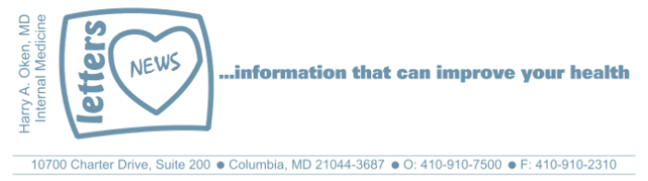
COVID-19-19 – April 1, 2020
Dear Patients,

The sobering news:
There was sobering news yesterday from the White House. The death projection, even the best case, is staggering. And it is quickly becoming a reality. Nonetheless, understand this: if you follow the advice, you are safe and you will be fine.

Reminders:
Stay home, you cannot get this unless you come in contact with the virus. So again, stay home!

You are safe if you isolate you and your family!

Grandparents: stay away from your grandchildren, they may be asymptomatic vectors. Use FaceTime!

Here is a great question posed by my grandson: https://youtu.be/RP1f7Iyiy6w

Shrink your social circle.

Go out only for emergency issues.

Sanitize between touches of foreign objects, door knobs outside your home, elevator buttons. Carry sanitizer with you; touch and sanitize.

Cut your fingernails close in so when you soap and water scrub, you can really get a deep clean.

If you cannot stop touching your face, wear a mask when you go outside your safe decontaminated home. There's no downside. If you wear a mask, do not let it give you a false sense of not being vulnerable.

If you have any respiratory symptoms whatsoever, definitely wear a mask or bandana to protect others from you (this is not presently consistent with CDC recommendations, but I think it is coming). N95 masks are for health care personnel only on the front lines. Here is some information about masks and sterilization of masks that is about 34 minutes.
(https://blogs.mercola.com/sites/vitalvotes/archive/2020/03/29/even-homemade-masks-can-help-stop-the-spread-of-sarscov2.aspx)

Check it out if you want, after all, are you doing anything else?

Maybe this is a bit much?? (thank you BH)

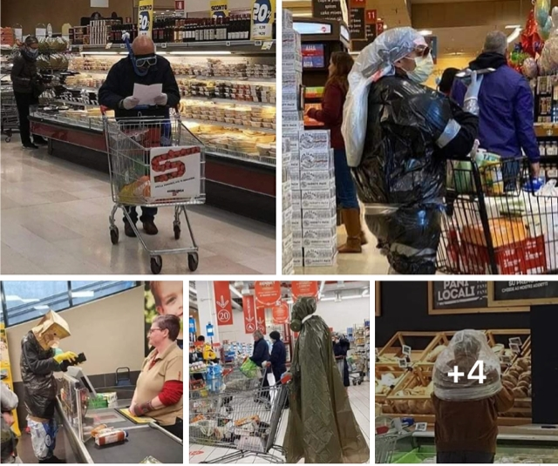

The numbers:
US: 189,633 cases 4,081 deaths 2.1% fatality rate (1,096 of the deaths in NYC alone)
Maryland: 1,985 cases 31 deaths 1.5% fatality rate
(11.5% of tests in MD are positive; 17,233 total tests; 522 have been hospitalized)

Preliminary evidence, according to the Surgeon General this AM, is showing that states where we are implementing early intervention are seeing some flattening of the curve. I was in touch with my colleague, the Chairman of the Department of Medicine at HCGH this AM, and he tells me we are currently in good shape there.

This model (https://covid19.healthdata.org/) currently predicts that in Maryland, we will peak at 51 deaths per day on May 1. Let's prove them wrong. You know what to do!

Therapeutics:
- More information is debunking the claim that NSAID use worsens COVID-19, stayed tuned for definitive guidance.
- Awaiting more information on the combo of Hydroxychloroquine + Azithromycin + zinc; hopefully most hospitals have it and are using it (true locally); earlier use seems to be better.
- Passive transfer of convalescent plasma is starting and is hopeful. Here's a link: (thanks WW)
https://www.biospecialty.com/covid-19-special-project?utm_campaign=COVID&utm_source=linkedin&utm_medium=social&utm_term=LinkedIn

On a musical note:
Today's music made me smile! (https://www.youtube.com/watch?v=dUzd9PII1ew)

And finally, on a lighter note:

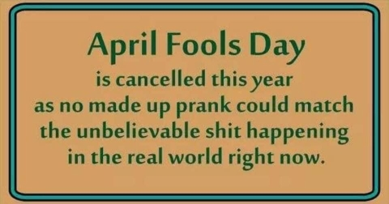

Harry A. Oken, M.D.
Office: 410-910-7500, Fax: 410-910-2310
Cell: 443-324-0823
Adjunct Professor of Medicine
University of Maryland School of Medicine

Question for Governor Hogan
From my grandson: https://youtu.be/RP1f7Iyiy6w

Video of the Day
Twins playing violins: https://www.youtube.com/watch?v=dUzd9PII1ew

Tips of the Day
- Homemade Masks:
- https://blogs.mercola.com/sites/vitalvotes/archive/2020/03/29/even-homemade-masks-can-help-stop-the-spread-of-sarscov2.aspx

- COVID-19 Projections: https://covid19.healthdata.org/
- COVID-19 Questionnaire: https://covid19.healthdata.org/

