
COVID-19-26 – April 8, 2020
Dear Patients,

COVID-19 Anxiety and Despair:
There is no doubt that this is the nightmare of our lifetimes. Awaking this morning and learning that the current death toll in NY is greater than several countries, including China, is very unsettling. Like any nightmare, you may wake up multiple times during the night asking yourself 'was that real?'. Then, going back to sleep, waking up again and again, with other nightmarish scenarios and finally arising, getting up and reading, watching, listening to the grim news. It is taking it's toll on all of us. There is great grief for the loss of people of all ages. There is tremendous worry and fear.

When will this end? Who will get sick next? If I get sick, will I recover?

Don't go there, just stick to the plan. Stay home and you will be safe. Stay home and you are a hero holding the line. Stay home as we are hosing this fire down. Stay home as an investment to ensure that next month, next year, and for years to follow, we can reclaim our lives.

Re-enforce your mental fortress:
Want a good read? The Art of the Good Life by Rolf Dobelli, is great! I paraphrased an excerpt below:
- Everything in life has highs and lows. Accept the existence of fate. This does not mean you cannot change your fate by creating what you get; so stay home, be safe.
- Everything we own and has value and love is ephemeral: your health, your partner, your children, your family, your house, your money, your status, your reputation. Everything is on loan. Relax and be glad if fate grants them to you.
- Remember that the positive has outweighed the negative in your life (or you wouldn't be complaining) and that all sweet things are tinged with bitterness.
- What cannot be taken from you are your thoughts. These are your mental tools, these tools determine the way you interpret bad luck, loss and setbacks. This space is your mental fortress, it is a piece of freedom that can never be taken from you. Stay in the present moment, learn from the past, plan for the future and stay home.
The numbers:
US: 399,929 cases 12,911 deaths 3.23% fatality rate (up)
Maryland: 5,529 cases 124 deaths 2.24% fatality rate (down)
(16.7% of tests in MD are positive; 32,933 total tests; 1,210 have been hospitalized)

Diagnostics and Therapeutics:
Ingenuity and innovation! As I've said before, necessity is the mother of invention!
- Hydroxychloroquine (HC)+Azithromycin+Zinc therapy - we are almost there with more information, may be by the end of the week. HC may change the pH in the cell and decrease viral replication.
- We are learning some valuable information about COVID-19. It turns out that the virus binds to glycoproteins on our own hemoglobin (carries oxygen) and then knocks off the iron. So the hypoxia (low oxygen) in part is from the inability of our red blood cells to carry oxygen. HC may interrupt the binding of the virus and keep it from pushing off the iron, so oxygen-carrying capacity does not decline. Blood transfusions with helpful antibodies may work. We are learning from Italy and Spain.
- We are also learning that the ventilators need to be on a low-pressure setting, not at a high-pressure setting. In an effort to improve oxygenation and avoid hypoxia early on, the ventilators were pushing in high pressures of air with the oxygen; we are now learning this may be causing a problem rather than solving the problem.
- Every day we are making progress, antivirals, therapeutics, ventilator management, vaccines and most importantly now, social mitigation.
On a musical note:
Let's rise above our worry and fear by Defying Gravity! Be in the moment and stay put!

On a lighter note:

Tonight begins the holiday of Passover. This holiday is celebrated, not by going to a synagogue, but by families gathering for a traditional Seder meal. Prior to the meal being served, there is traditionally a service where the story of the exodus of the Jewish people from Egypt is told. The hallmark of this service is when the youngest child in attendance (yes, you, SFG) reads 'The Four Questions'. These questions highlight the ways in which Passover customs and foods distinguish the holiday from other times of the year and starts with "Why is this night different from all other nights?". For most of the world, tonight, like all of our recent nights, will be different from all other nights. For my entire life, my family has gathered for Passover. Tonight will be different from all others. Cherish your family. I miss mine, particularly tonight.  For the lighter note, for those of you who celebrate Passover, here is a photo of our revised Seder Plate: | 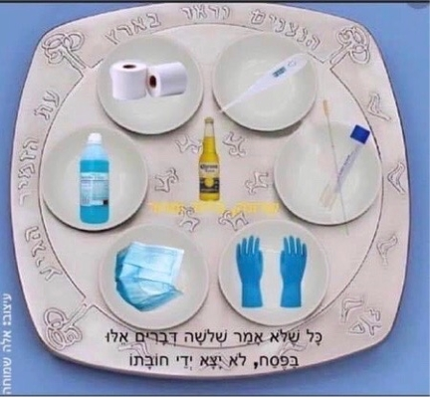

Reach out. Stay connected. Stay home. Save lives. The power of one. Be well.
HAO
24/7

Harry A. Oken, M.D.
Office: 410-910-7500, Fax: 410-910-2310
Cell: 443-324-0823
Adjunct Professor of Medicine
University of Maryland School of Medicine

Videos of the Day
- Idina Menzel - Defying Gravity (from LIVE: Barefoot at the Symphony): https://www.youtube.com/watch?reload=9&v=MslDnwerQRA

