
COVID-19-02 – March 15, 2020
Hello everyone,

I just want to let you know you are not alone in this; I am available for your issues and questions 24/7.

Purposely, I am limiting face to face office hours; telemedicine will make up for this as much as possible. To the extent possible, I want to limit traffic into my building and waiting room. If you have any respiratory symptoms, DO NOT COME TO THE OFFICE, call me and we will decide how to address the issue!

If you are over 60, your immune system is likely not as robust as it used to be. If you are younger and have other underlying issues (diabetes, lung, heart issues, autoimmune issues or undergoing treatment for cancer, etc) yes, you are at higher risk. Again, be smart. Based on current CDC recommendations, I am postponing routine office visits for all patients over 60. Cancel elective procedures. Do not get your shingles vaccination now so we can avoid confusion of a side effect vs something else.

Be smart, we are all in this together and we need to make sacrifices for the good of each and every one of us.

There are currently 27+ COVID-19 patients in Maryland. Of course, this vastly underestimates the prevalence. Want more reassurance, see the link below.

https://theconversation.com/coronavirus-ten-reasons-why-you-ought-not-to-panic-132941

My current thoughts:
- The next 10 to 14 days will tell the story.
- Testing will be more available, no need to get tested unless you have symptoms.
- We will see progressive recommendations to stay put. Be ahead of the curve. Stay put!
- An abundance of caution for contact with others is the way we avoid a surge of cases.
- A surge means up to 20% of the infected people will need some sort of attention, some will need to be in the hospital.
Process these curves and you will know what to do! Everyone must participate to avoid the surge. Be smart--stay put!

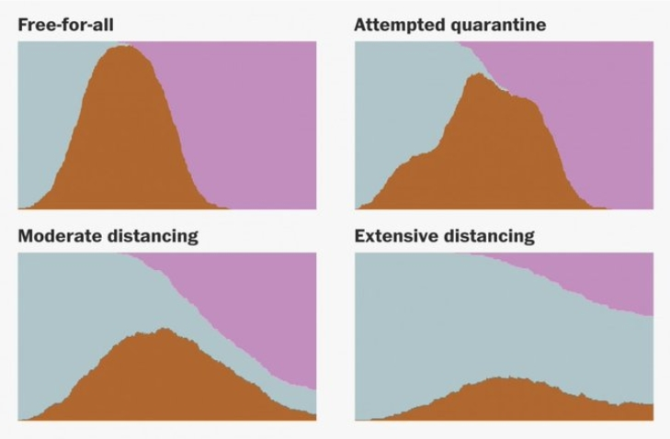

Major do's:
- Stay calm with pleasurable distractions.
- Get your rest.
- Get your exercise. If you decide to go to the gym (if it remains open) employ social distancing >3 ft.
- Eat well including plenty of veggies and fruit.
- Stay away from crowds.
- Wash your hands with soap and water often.
Major don'ts:
- Shake hands, embrace or a kiss
- Do not visit the hospital, group homes or rehab centers
- Do not get your shingles vaccination at present
Be smart, do not panic, be well, stay tuned--HAO

Lastly, on a lighter note to inject some humor in your day (thanks Brix):



Harry A. Oken, M.D.
Office: 410-910-7500, Fax: 410-910-2310
Cell: 443-324-0823

Adjunct Professor of Medicine
University of Maryland School of Medicine

Confidentiality Statement:
This email message, including any attachments, is for the sole use of the intended recipient(s) and may contain confidential and privileged information. Any unauthorized use, disclosure or distribution is prohibited. If you are not the intended recipient, please contact the sender by reply email and destroy all copies of the original message.

