
COVID-19-32 – April 14, 2020
Dear Patients,

First, we had some additional technical email issues yesterday that should be resolved for good. The size of our email list has grown therefore we needed to create a new platform to be able to send out our Daily Update. I truly appreciate your positive comments, support and readership. And as I mention at the bottom, feel free to forward this on.

Okay, we are definitely making progress. Things really are looking better and yet you may be thinking 'how in the world am I going to be able to keep this up? I am getting antsy, or I've been furloughed, or even worse, I'm not even sure I have a job to return to. And the government has promised me relief, a grant, a small business loan and nothing is happening, except I am stuck here sheltering in place.'

If you are feeling it, I got it. I understand. Now that we have seen some results and perhaps there is a light at the end of the tunnel, now is the time for mental endurance. But how?

- Positive self-talk, like 'I will get through today.' It's a long journey and we'll get there, one step at a time
- Have a plan. Make lists every day of what you want to accomplish. At the end of the day, cross off those accomplishments.
- Even though being stuck at home seems endless, know that there was a beginning and there will be an end.
- Weed your mind. Throw out those bad thoughts. Yes, just like you are weeding your garden, clear out the weeds then plant good seeds. 'I can do this!' You might like this video - part of Navy SEAL training.

What lies behind us and what lies before us are tiny matters compared to what lies within us. Ralph Waldo Emerson

The numbers:

US: 582,594 cases 23,649 deaths 4.0% fatality rate (up)
Maryland: 9,472 cases 302 deaths 3.2% fatality rate (up)

In NYC, the daily number of hospitalizations is down. NYC has the resources that it needs. It is still a battle zone with too many casualties. The front-line warriors are exhausted but their efforts have saved lives. New Yorkers themselves are heroes for staying at home. My youngest daughter lives and works in Manhattan and returned there yesterday. At 7pm every night, when many healthcare workers are changing shift, there are cheers; from their homes and apartments, people open their windows and yell and bang pots and pans to cheer on the health care providers. We heard it last night while Face Timing with her. Hail to this country's heroes who are going forward in the face of adversity and fear; this is the definition of courage. Here's a clip to watch this moving tribute: https://secretnyc.co/videos-new-yorkers-clapping-essential-workers/

Locally, at HCGH, the ER and hospital are in good shape. There are two large white tents in front of the Ambulatory Surgery building. Should we have a surge, we are very ready. Our Governor has helped immensely to keep us prepared. Here is our model for Maryland. The model was just updated and suggests we peaked for hospital resource use on April 11. Although the total projected number of deaths for the US is still projected to be 68,000, I am optimistic that this will be significantly less. Why? We are quickly learning about the pathophysiology of this virus, particularly how to support the respiratory issues that arise with ventilator protocols that do not over-stress the lungs and improve oxygen delivery.

Diagnostics and Therapeutics:
- Antibody testing is still needed and not readily available yet. Recovering patients who are interested in giving convalescent serum that contains antibodies are being tested and if their antibody levels are high enough, they can donate their plasma to be used in treating critically ill patients. It is not known with certainty that this will be effective, but it is a reasonable strategy.
- A saliva test for detecting active infection has been developed at Rutgers and received emergency approval.
- Interest in hydroxychloroquine alone and in combination with azithromycin continues. It is being used by many physicians as an 'off label' therapy. I have prescribed it with success for a few patients. Time will tell if it has true clinical utility.
- Our understanding about how to treat COVID-19 induced severe respiratory disease is rapidly improving.

On a musical note:
Carry On: https://www.youtube.com/watch?v=lh67x9iDCjg

And on a lighter note:

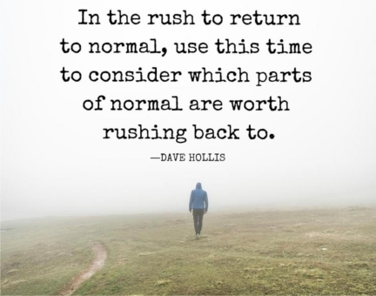

Reach out. Stay connected. Stay home. Save lives. The power of one. Be well.
HAO
24/7

Harry A. Oken, M.D.
Office: 410-910-7500, Fax: 410-910-2310
Cell: 443-324-0823
Adjunct Professor of Medicine
University of Maryland School of Medicine

Videos of the Day
- Navy Seal Training: https://www.youtube.com/watch?reload=9&v=nQRRDs-Vrtc
- A Beautiful Moment: https://secretnyc.co/videos-new-yorkers-clapping-essential-workers/
- Carry On: https://www.youtube.com/watch?v=lh67x9iDCjg

Tips of the Day
- COVID19 Projections for Maryland: https://covid19.healthdata.org/united-states-of-america/maryland
- Saliva-based test nets FDA green light for COVID-19:
https://www.fiercebiotech.com/medtech/rutgers-saliva-based-test-nets-fda-greenlight-for-covid-19

