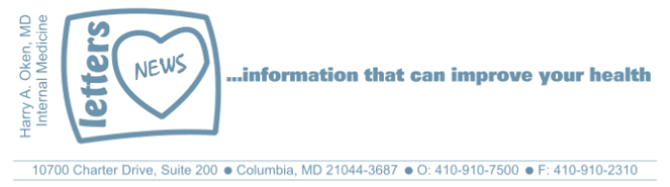
COVID-19-33 – April 15, 2020
Dear Patients,

First, we are getting closer to resolving our email issues, although we've been told that now that we've switched to using ConstantContact as our server, our Daily Update is often showing up in spam folders. If you know of someone who says they didn't receive it, let them know to check their spam. We are working with ConstantContact to rectify this.

So, what's new? First, keep your chin up! By all accounts, we have, at minimum, stabilized and I believe we are making progress. The day is coming when we can start to slowly relax our sheltering. Yes, we will need face coverings outside our safe areas. Yes, we will need social distancing of at least 6 feet. Yes, we will need hand sanitization or soap and water. Ok, the question is "when?" I am not sure, but I believe it may start within 2-4 weeks. And, it will be a slow roll-out. It will be layered and it may differ for different people, possibly by age, zip codes, counties, states.

One other thing, many of us are struggling with being at home and having lots of negative thoughts. Remember that how you think is how you feel and how you feel is how you think. So, how can we deal with this? If you have a negative thought, acknowledge it and push it out. Say out loud "not now" or "no thank you"; saying it out loud makes it real. If someone gives you a negative thought, say "no thank you." That way, they own it, not you! This is a way of developing mental toughness. Your mental armor will be resilient and impenetrable. The goal is to be present and imperturbable. This will serve you well.

Take a moment to cement this in and watch this. (2:22 min)

The numbers:

US: 609,685 cases 26,059 deaths 4.27% fatality rate (up)
Maryland: 10,032 cases 349 deaths 3.4% fatality rate (up)

In NYC, they continue to stabilize.
Locally, at HCGH, as of this AM, the ER and hospital are in good shape.

Risks for getting COVID-19 continue to be defined. For sure you are at increased risk for a significant infection if your age is >60, history of heart disease, lung disease, diabetes or kidney disease. Published today is new information finding obesity as a risk factor. As we get closer to our freedom and transitioning to normal, I will provide some guidance in tackling this prevalent issue that is a significant threat to our vulnerability to not only contracting COVID-19, but multiple other issues.

Diagnostics and Therapeutics:
- Stems cells were used to reverse respiratory failure in COVID-19 patients (Adult Respiratory Distress Syndrome). This is very promising.
- ICU physicians are learning innovative ways of improving outcomes for those patients with respiratory failure.

On a musical note:
Pharrell Williams: Happy

And on a lighter note:



Reach out. Stay connected. Stay home. Save lives. The power of one. Be well.
HAO
24/7

Harry A. Oken, M.D.
Office: 410-910-7500, Fax: 410-910-2310
Cell: 443-324-0823
Adjunct Professor of Medicine
University of Maryland School of Medicine

Videos of the Day
- How to Defeat Negative Thinking: An Animation: https://www.youtube.com/watch?v=_XLY_XXBQWE
- Pharrell Williams – Happy: https://www.youtube.com/watch?v=ZbZSe6N_BXs

Tips of the Day
- Factors associated with hospitalization of COVID-19 patients in NYC:
https://www.medrxiv.org/content/10.1101/2020.04.08.20057794v1
- Israeli COVID-19 treatment: https://www.jpost.com/HEALTH-SCIENCE/Israeli-COVID-19-treatment-with-100-percent-success-rate-tested-on-US-patient-624653

