
COVID-19-51 – May 5, 2020
Dear Patients,

Now that it is getting warmer out, the sunny days make it harder and harder to contain ourselves. In Maryland, we are still in lock-down mode. Even though we have a roof over our heads, we have food to eat, we have computers, phones, Netflix, etc., we may still feel deprived or that we are making a huge sacrifice.

Let me challenge you to take a different view. The vast majority of us have come through this ordeal with our health and a new appreciation of our lives. Yet, I get it, it feels like 'okay already, when is this going to end?' The answer is that this is our new life for weeks and months to come, and as we move into our new reality, we need to accommodate to our new social norms. And as the viral threat slowly diminishes, we will have a new appreciation for some of the simpler pleasures of everyday life: the value of a hug or handshake, a get-together with family and friends, a vacation to a faraway place. All of these simple pleasures will eventually be part of our lives. But we must wait.

In the meantime, let's be thankful for what we have and do everything we can to improve our health. In many ways, reinforcing and working towards better health is the single most important factor to put the odds on your side for a long and happy life. Don't take your health for granted. Let's work towards optimizing it. And this takes strength and willpower!

The numbers: Maryland:
27,117 cases -/- 1,290 deaths -/- 4.76% fatality rate

The Maryland Ro: (see April 22 Update for explanation of Ro) No real change, we remain in the green zone, 0.89; lower is better.

My big announcement: Finally, after 8 years, my book, that I co-authored with my friend and mentor from Medical School, Steve Schimpff, MD, is going live. BOOM! Boost Our Own Metabolism: A Guide to a Better Life is almost here as both an e-book and paperback!  This book has been a labor of love for me, and in that spirit, I am thrilled to announce that 100% of the profits are being donated to The University of Maryland Medical Center (UMMC) and COVID-19 research, headed by Greg Schrank, MD, MPH. Dr. Schrank is an epidemiologist with the UMMC Institute of Virology/Infectious Disease and co-chair of their COVID-19 Preparedness and Response Committee. | 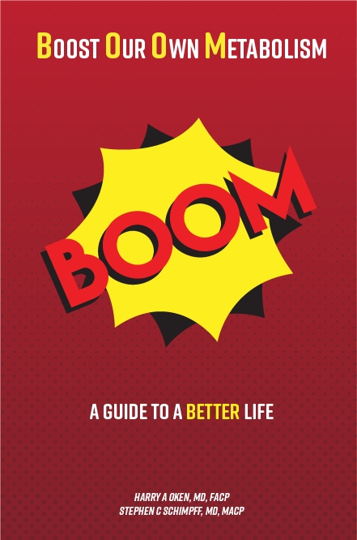
On a lighter note.


On a Musical Note: This is from one of my favorite shows. I'm hoping that my book, BOOM, will make the earth move under your feet!


Reach out. Stay connected. Stay home. Save lives. The power of one. Be well.
Feel free to forward this on: spread the word, not the virus.

HAO
24/7

Harry A. Oken, M.D.
Office: 410-910-7500, Fax: 410-910-2310
Cell: 443-324-0823
Adjunct Professor of Medicine
University of Maryland School of Medicine

Links for Today
- Feel the Earth Move, Carol King: https://www.youtube.com/watch?v=pWJMh2wbPgE
- We remain in the Green Zone:
https://rt.live/?fbclid=IwAR1wdbbX1wtiPpnATDwr1fqRzgTXQZhomcO1lCk6bGrxae0ia8KUWOSa2HM#FL

