
COVID-19-56 – May 11, 2020
Dear Patients,

I hope you had a great Mother's Day weekend. Locally, on Sunday, the sky was blue and as the day's chilly air slowly warmed, all seemed almost back to normal...well, not quite.

Some of my immediate family sat on our deck with ample distance between one another and we talked about what our summer might look like. Yesterday, there was more optimism that things are slowly changing. We now know, with more evidence than before, that the coronavirus may only be able to survive for literally just minutes in the sun, and being outdoors also minimizes the risk of spread from person to person. Welcome sunny and warm days ahead!

Nonetheless, we are in agreement to keep our distance from one another, wear our masks when out and about. And continue to use hand sanitizer when out of a safe zone. We need to continue to resist the natural tendency to shake hands, hug and kiss...and not being afraid to admit you miss these simple socialization staples of daily life.

"The things we take for granted, someone else is praying for."

And on this Mother's Day, I will be grateful for my wife, a terrific mom, and our kids and grandson.

The numbers: Maryland: 33,373 cases -/- 1,544 deaths -/- 4.7% fatality rate Close to 2/3 of the deaths in Maryland are those over the age of 70.

The Maryland Rt was updated on 5/10 and is 0.98 (tracking upward); the lower the better. Note that the model was updated (explaining the change from Ro to Rt) to reflect corrections for the amount of testing done over time in each state. An increase or decrease in testing in each state should not affect the accuracy of values in the future.

Diagnostics and Therapeutics:

- Roche now has an antibody test with very high specificity and sensitivity. In other words, if antibodies are present, it will accurately (99%) find it (100%) and we do believe that antibodies are likely to confer some degree of immunity.
- Pluristem Therapeutics uses placenta cells to modulate the extensive inflammation found in patients with COVID-19 respiratory failure. The FDA has approved a Phase II trial, it looks like a promising approach.
My book update: Just as a reminder, it's here - both as a paperback and Kindle e-book! ﻿ I have one request of you when you finish reading this email, and that is, to please consider purchasing a copy or copies of my book to help fund important COVID-19 research.

 | 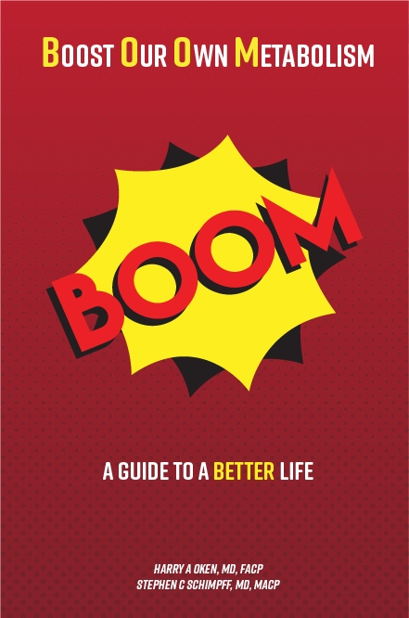
  Please consider purchasing a copy or copies today. Remember, all proceeds benefit COVID-19 research at the University of Maryland Medical Center. Ordering instructions are below.
  

Instructions for ordering the book:
Paperback version - Click here to go directly to Amazon.

Kindle e-book –
- If you are purchasing the Kindle e-book from a computer/laptop, click here to have the e-book version delivered to a Kindle app on your tablet or phone. This is the easiest method. Note, you will need to have the Kindle app installed on your tablet or phone. To do this, go to the App Store.
- If you are purchasing the Kindle e-book from an iPad or iPhone, you'll need to have the Kindle app installed. Open Safari on your device and go to this link. Then, in the top search bar, type in 'Oken BOOM' and it will bring you to the page to purchase it.

On a Musical Note: The older I get, the more closely I listen to the lyrics of songs. This is one of my favorites, My Wish for You for You by Rascal Flatts.


On a lighter note:


Reach out. Stay connected. Stay home. Save lives. The power of one. Be well.
Feel free to forward this on: spread the word, not the virus.

HAO, 24/7
Harry A. Oken, M.D.
Office: 410-910-7500, Fax: 410-910-2310, Cell: 443-324-0823
Adjunct Professor of Medicine, University of Maryland School of Medicine

Links for Today
- Rachal Flatts, My Wish: https://www.youtube.com/watch?v=zGB7IWklW3s
- Roche now has an antibody test: https://www.roche.com/media/releases/med-cor-2020-05-03.htm
- The Maryland Rt: https://rt.live/?fbclid=IwAR1wdbbX1wtiPpnATDwr1fqRzgTXQZhomcO1lCk6bGrxae0ia8KUWOSa2HM#FL
- Pluristem Therapeutics: https://www.globenewswire.com/news-release/2020/05/08/2030212/0/en/U-S-FDA-Clears-Pluristem-s-IND-Application-for-Phase-II-COVID-19-Study.html
- BOOM, paperback version: https://www.amazon.com/dp/B088B4PVZD/ref=sr_1_1?keywords=boom+oken&qid=1589025147&sr=8-1
- BOOM, Kindle version: https://www.amazon.com/BOOM-Boost-Our-Own-Metabolism-ebook/dp/B0882VV9K3/ref=tmm_kin_swatch_0?_encoding=UTF8&qid=1589025147&sr=8-1
- BOOM, app for iPad/iPod: https://www.amazon.com/Kindle-Store/b?ie=UTF8&node=133140011

