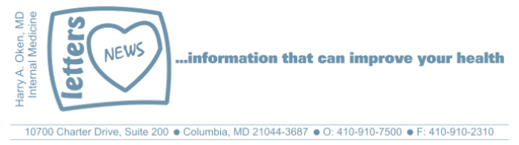
COVID-19-57 – May 12, 2020
Dear Patients,

Yesterday was the fourth consecutive day that Maryland has seen a decrease in hospitalizations due to COVID-19. However, we topped 80,000 deaths nationwide, which has surpassed all annual influenza deaths during the past 50 years. Dr. Fauci is scheduled to testify before the Senate today and is expected to warn that reopening the US too quickly could bring "suffering and death." Maryland is addressing a hot spot on the Eastern Shore, the home of Perdue Farms. Meat processing plants have been hit hard with many workers contained in close quarters.

Every day we are learning more about the intrinsic biology of COVID-19. We better understand transmission, testing and supportive care. Some initial findings have not changed; up to 50% of people get asymptomatic infections and another 30% get only mild infections. Presently, there is a 4-5% fatality rate in the US. In Maryland, up to 50% of the deaths are from nursing facilities and close to 80% are over the age of 70. We must proceed slowly with an incremental, data-driven re-opening; otherwise we will create a more disastrous outcome.

A review of things we can do to stay well:
- Protect our most vulnerable: the elderly and people with co-morbidities.
- Regular testing in chronic care facilities appears to be an effective tool in minimizing exposure to the vulnerable.
- Wear a face mask when out of your safe zone.
- Good hand hygiene.
- Get sunshine and socialize outside with appropriate distancing.
- Eat well, get sleep and exercise.
- Take Vitamin D-3, 2000 units per day
- Address your stress and anxiety; talk about it, meditate, do deep breathing, call a friend, distract yourself with pleasurable activities.
- Read a book, such as BOOM! (see below).

"Anxiety does not empty tomorrow of its sorrows,
but only empties today of its strength."
- Charles Spurgeon

The numbers:
Maryland: 34,061 cases -/- 1,563 deaths -/- 4.6% fatality rate
2/3 of the deaths in Maryland are those over the age of 70.

The Maryland Rt was updated yesterday and is 0.98 (stable); the lower the better.

Diagnostics and Therapeutics: Nothing new to report.

My book update:

Another reminder, it's here - both as a paperback and Kindle e-book! ﻿ I have one request of you when you finish reading this email if you haven't already done so, and that is to please consider purchasing a copy or copies of my book to help fund important COVID-19 research.

 | 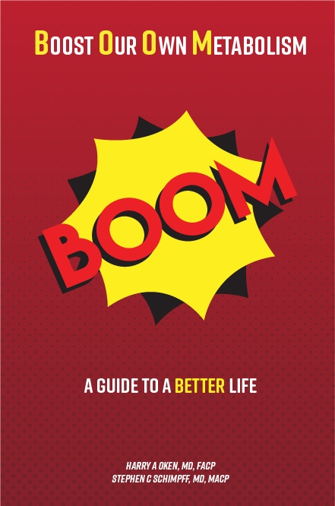
  Please consider purchasing a copy or copies today. Remember, all proceeds benefit COVID-19 research at the University of Maryland Medical Center. Ordering instructions are below.
  

Instructions for ordering the book:

- Paperback version - Click here to go directly to Amazon.
- Kindle e-book -
- If you are purchasing the Kindle e-book from a computer/laptop, click here to have the e-book version delivered to a Kindle app on your tablet or phone. This is the easiest method. Note, you will need to have the Kindle app installed on your tablet or phone. To do this, go to the App Store.
- If you are purchasing the Kindle e-book from an iPad or iPhone, you'll need to have the Kindle app installed. Open Safari on your device and go to this link. Then, in the top search bar, type in 'Oken BOOM' and it will bring you to the page to purchase it.

On a Musical Note:  Yes, this seems like it's been the longest time (thank you very much TB)! | 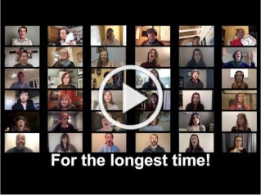

On a lighter note: (thanks SO)
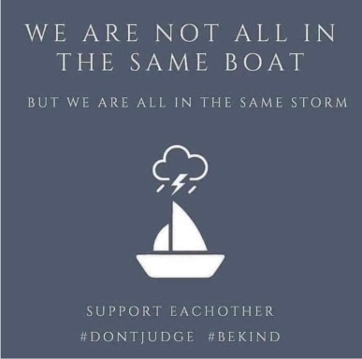

Reach out. Stay connected. Stay home. Save lives. The power of one. Be well.
Feel free to forward this on: spread the word, not the virus.

HAO, 24/7
Harry A. Oken, M.D.
Office: 410-910-7500, Fax: 410-910-2310, Cell: 443-324-0823
Adjunct Professor of Medicine, University of Maryland School of Medicine

Links for Today
- Longest Time, Quarantine https://www.youtube.com/watch?v=LpAKcQufacc
- Boom Paperback: https://www.amazon.com/dp/B088B4PVZD/ref=sr_1_1?keywords=boom+oken&qid=1589025147&sr=8-1
- Boom, Kindle version:
https://www.amazon.com/BOOM-Boost-Our-Own-Metabolism-ebook/dp/B0882VV9K3/ref=tmm_kin_swatch_0?_encoding=UTF8&qid=1589025147&sr=8-1
- Kindle app: https://www.amazon.com/Kindle-Store/b?ie=UTF8&node=133140011

