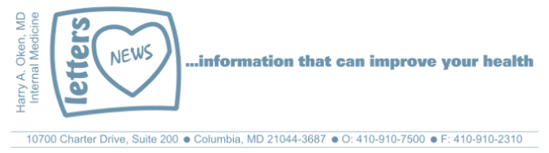
COVID-19-06 – March 18, 2020

This made me smile yesterday; click here and listen while you read below.

Understanding where we are
We will continue to see a doubling in the number of cases every 2 to 3 days. This does not mean that we are not flattening the surge of infections. It reflects the fact that we are increasing our testing and therefore we are discovering the prevalence of the infection. We will see significant numbers as testing increases. Hopefully, however, our fatality rate will be low.

If we look at Germany, they started testing long before us (15 days). Currently, they have 6,000 cases and yet they have had only have 6 deaths (death rate = 0.1%). In the US, 42 of the deaths have been in a Washington State nursing home which was home to extremely vulnerable patients. So our current death rate is approximately 1%.

I have been in touch with Howard County General Hospital every day; so far, all is under control. We are as ready as we can be.

Testing in Howard County
As of today, HCGH has developed a drive-through facility. At present, the logistics are being worked out so I don't have the exact details quite yet. I'll keep you posted.
Below is the algorithm to determine if and when to be tested:

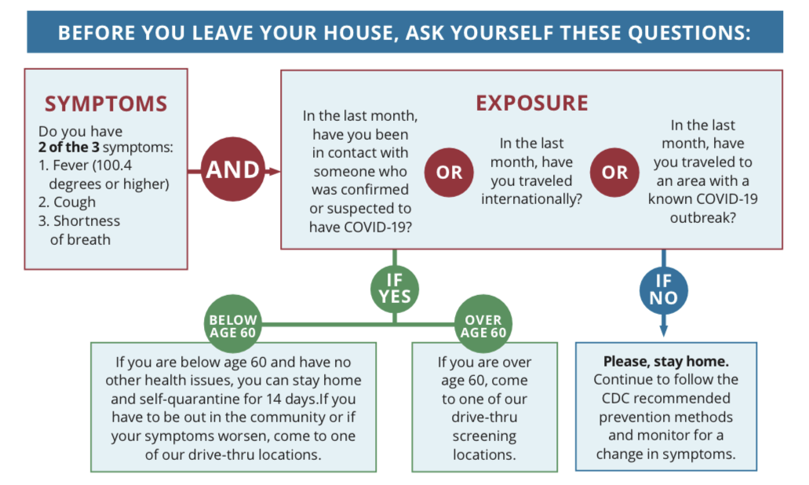

If you feel you need to be tested, call me and I will help guide you in a decision.

Other issues
- Careful about scammers on the internet; they are out there fishing to sell supplements and personal protection.
- Can I exercise outside? YES! Employ social distancing on runs, walks and bike rides!
- Should I have home oxygen at home just in case? NO! If you need oxygen, you need to be in the hospital!

Again, stay put and stay well! Listen to classic rock--my favorite! (Click or copy and paste this link: https://www.youtube.com/watch?reload=9&v=DVl-oX)

I'm available 24/7.

Harry A. Oken, M.D.
Office: 410-910-7500, Fax: 410-910-2310
Cell: 443-324-0823
Adjunct Professor of Medicine
University of Maryland School of Medicine

Confidentiality Statement:
This email message, including any attachments, is for the sole use of the intended recipient(s) and may contain confidential and privileged information. Any unauthorized use, disclosure or distribution is prohibited. If you are not the intended recipient, please contact the sender by reply email and destroy all copies of the original message.

