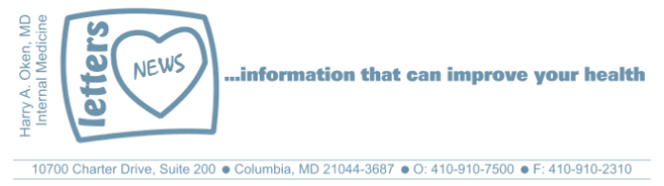
COVID-19-63 – May 20, 2020
Dear Patients,

This is my 65th daily update during the COVID pandemic. I hope that my daily musings have helped you find strength and optimism. I've strived to create some literary alchemy, taking fear and worry and turning it into optimism, strength, and courage.

So often in medicine, we start down a road that has twists and turns, sometimes moving slowly and other times quickly. Medical stories unfold, and looking back, we think: hmmm, I wish I would have known that when this all started. We treat the primary problem and then secondary and tertiary issues are often created by our initial intervention. Of course, this is not just limited to medicine, this is life.

Now more than ever, we have clarity. We better understand the COVID biology, its transmission, its infectivity, its incubation, and the variability of its clinical presentation as well as its effects. We have better tools to diagnose and treat it and there is reason to believe a vaccine is on the horizon. Still, the exact path forward is a climbing, winding road. Our strength was tested and we are now stronger, more confident and less fearful than we were 65 days ago. And that strength will continue to carry us forward. Not everyone will feel this way; some may challenge the need for the lock down, a face-mask, or the necessity of school closings. There are logical reasons to question and fine-tune these maneuvers. And we should so we can keep moving forward with confidence and precision.

Almost every day of the past 65 days I witnessed the fact that people don't like living in a vacuum. I also witnessed acts of bravery, kindness, and courage. People from all walks of life came together to support one another and many looked into their own darkness and found a strength they were previously unaware they had. Observing people pull together and persevere during probably the most unusual time in our lives gave me goosebumps, sometimes made me misty-eyed and I often felt a special feeling in my heart. You probably did too. There are lots of things wrong in our country, but there are many more things that are right!

"Yeah, I got all I need
And it's alright by me"
Alright by Darius Rucker

The numbers:
Maryland: 42,324 cases -/- 2,004 deaths -/- 4.7% fatality rate
Greater than 50% of the deaths in Maryland continue to be nursing facility residents or staff.
The Maryland Rt was updated yesterday and is 0.93 (down slightly); the lower the better.

Diagnostics and Therapeutics:
- Testing in Maryland has surpassed 200,000 (3.5% of the population). You can now be tested even if you have no symptoms and no appointment is necessary.
- Pediatric multisystem inflammatory syndrome (PMIS) is a rare and serious condition in children that starts as a rash and sometimes with enlarged lymph nodes and appears days to weeks after an asymptomatic COVID infection. It seems to be an over-reaction of the immune system. Now knowing this, early treatment seems to be effective.

My book update:
Thank you to all who have made a donation by purchasing my book. I truly appreciate it! If you haven't made a purchase, if these daily emails have touched you, soothed you, reassured you in anyway, please let me know by making a donation by purchasing BOOM!

If you've already purchased BOOM, please go back into your Amazon account, in the search bar at the top, type "BOOM and Oken" and write a review! These reviews are really important (and so far we don't have any)!

 | 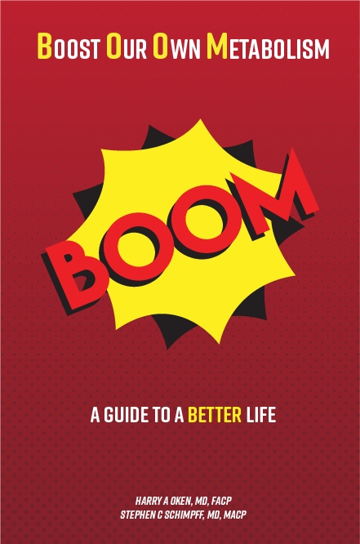
  Please consider purchasing a copy or copies today. Remember, all proceeds benefit COVID-19 research at the University of Maryland Medical Center. Ordering instructions are below.
  

On a Musical Note: This song celebrates the simple pleasures of life. Darius Rucker, ‘Alright’.

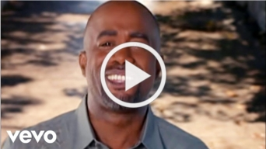

On a lighter note: The mascot of 2020.


Reach out. Stay connected. Stay home. Save lives. The power of one. Be well.
Feel free to forward this on: spread the word, not the virus.

HAO, 24/7
Harry A. Oken, M.D.
Office: 410-910-7500, Fax: 410-910-2310, Cell: 443-324-0823
Adjunct Professor of Medicine, University of Maryland School of Medicine

Links for Today
- Darius Rucker, ‘Alright’: https://www.youtube.com/watch?v=etr7UtnUflM
- Critical Milestone in COVID-19 Testing Strategy: https://governor.maryland.gov/2020/05/19/governor-hogan-announces-critical-milestone-in-covid-19-testing-strategy-as-state-broadens-criteria-for-testing-dramatically-expands-testing-availability-statewide/
- The Maryland Rt: https://rt.live/?fbclid=IwAR1wdbbX1wtiPpnATDwr1fqRzgTXQZhomcO1lCk6bGrxae0ia8KUWOSa2HM#FL
- Boom Paperback: https://www.amazon.com/dp/B088B4PVZD/ref=sr_1_1?keywords=boom+oken&qid=1589025147&sr=8-1
- Boom, Kindle version:
https://www.amazon.com/BOOM-Boost-Our-Own-Metabolism-ebook/dp/B0882VV9K3/ref=tmm_kin_swatch_0?_encoding=UTF8&qid=1589025147&sr=8-1
- Kindle app: https://www.amazon.com/Kindle-Store/b?ie=UTF8&node=133140011

