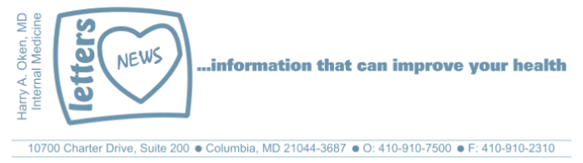
COVID-19-65 – May 22/23/24, 2020
Dear Patients,

Yesterday, or a week ago, or 2 months ago, everything you, your family, your coworkers, and friends have been through has brought you to today.

How are you doing? You have made it to today. Maybe it seemed that over the past 8 weeks you were doomed, but no, you are here. And now, in this very moment, you are engaged, focusing on this thought, you made it and you are here. Being in the moment, not obsessing on the past, not projecting into the future, not worrying about what is to come. In this moment, actually here, is not ordinary, it is perfect.

Being in the moment does not mean you forget about the past, which you cannot change, the past is what we learn from. And the future? It is what we plan for in the moment; not worrying about it or dreading it. This moment can be used to plan. Some people have trouble committing to the moment. It can be hard to get there and stay there. Some people just think that their life is just too complicated, too difficult to be in the moment. To them I say, think about this:

There are so many situations in life that can get us down: a relationship gone sour, an incapacitating illness, the loss of a loved one or friend. Or the daily turmoil we see playing out in the world. And now, how about a pandemic with 300,000+ worldwide deaths and counting?

You may enjoy this passage from Scott Peck's The Road Less Traveled. I read it periodically when I am trying to understand why bad things happen.

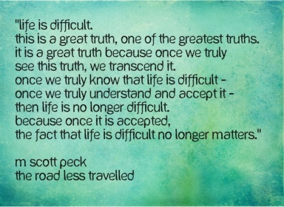

Also, from The Road Less Traveled:
Most do not fully see this truth that life is difficult. Instead they moan more or less incessantly, noisily or subtly, about the enormity of their problems, their burdens, and their difficulties as if life should be easy. They voice their belief, noisily or subtly, that their difficulties represent a unique kind of affliction that should not be and that has somehow been especially visited upon them, or else upon their families, their tribe, their class, their nation, their race or even their species, and not upon others. I know about this moaning because I have done my share.

"I, not events, have the power to make me happy or unhappy today.
I can choose which it shall be.
Yesterday is dead, tomorrow hasn't arrived yet.
I have just one day, today, and I'm going to be happy in it."
Groucho Marx

The numbers:
Maryland: 44,424 cases -/- 2,092 deaths -/- 4.7% fatality rate
Greater than 50% of the deaths in Maryland continue to be nursing facility residents or staff.
The Maryland Rt was updated today and is 0.96 (down slightly); the lower the better.

Diagnostics and Therapeutics:
- Oxford University coronavirus vaccine study is entering the next phase with 10,000 participants.
- Anticoagulation in patients with severe COVID-19 respiratory failure seems to improve outcomes.
- An innovative Cytokine filter has been used with success in patients with multi-system failure due to COVID-19.

My book update:
Thanks to all of you who have purchased BOOM, 100% of the profits are going to support COVID-19 research at the University of Maryland.

 | 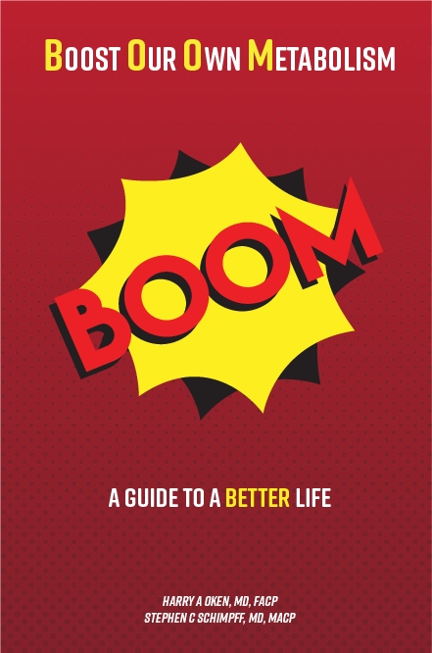
  

On a Musical Note: Yesterday by the Beatles


On a lighter note:



And finally, starting next week, I'll no longer be sending out daily updates and instead, I'll be updating you periodically as things change. Why? Because we have flattened the curve and it's time to slowly start back to Takin' Care of Business (click it and rock)! Just like yesterday, face masks, social distancing, hand washing and/or sanitizer whenever you need to leave your safe zone. Stay home if you display any symptoms.

I have enjoyed writing these almost daily updates. Initially, these were only sent to my patients, however, I've been humbled to learn that, through social media, these writings have been forwarded and re-forwarded to many. This has brought me great joy to know that this simple act of sharing facts, thoughts, opinions, and hopes have touched you in some way. Hopefully I've been able to reassure you, maybe make you smile and laugh, soothe your worries, and comfort you. And maybe, just maybe, I've helped you to be in the moment!

Reach out. Stay connected. Stay home. Save lives. The power of one. Be well.
Feel free to forward this on: spread the word, not the virus.

HAO, 24/7
Harry A. Oken, M.D.
Office: 410-910-7500, Fax: 410-910-2310, Cell: 443-324-0823
Adjunct Professor of Medicine, University of Maryland School of Medicine

Links for Today
- Yesterday, by the Beatles: https://www.youtube.com/watch?v=IMajkpYw2sI
- The Maryland Rt: https://rt.live/?fbclid=IwAR1wdbbX1wtiPpnATDwr1fqRzgTXQZhomcO1lCk6bGrxae0ia8KUWOSa2HM#FL
- Anticoagulation in patients: https://www.onlinejacc.org/content/early/2020/05/05/j.jacc.2020.05.001
- Cytokine filter: https://www.tmj4.com/rebound/could-this-blood-filter-not-yet-fda-approved-save-covid-19-patients
- Takin’ Care of Business: https://www.youtube.com/watch?v=ybtl9qVFAjc&list=RDybtl9qVFAjc&start_radio=1&t=0

