
COVID-19-71 – October 20, 2020
Dear Patients:

In my last COVID update, the song I used was Woodstock by CSN&Y and it seemed to bring back some great memories for many of you. Music is good medicine. Recently, I was listening to a classic rock mix (my favorite music genre) and I heard this song (please click now). Glory of Love just hits me; it's actually a neurologic thing with me. It happens sometimes at Broadway musicals: a knot in my throat and tears in my eyes. At the right time, the right tune, music can provoke an emotional reaction for many. Peter Cetera, formerly of Chicago, sings this cheesy song and yet to me, it makes me feel grateful. We are all in this together, we are a community. If we nurture ourselves with good nutrition, regular exercise, restorative sleep, and control our stress, then we can take care of our family, friends, co-workers, etc. - the people who depend on us; this is a selfless act.

Want a good book about this? BOOM! All proceeds go to University of Maryland COVID-19 research.

When you "stumble" on to a song you haven't heard for a while, is it an accident? Is it by chance? Is it by fate? In my opinion, it's probably chance, but what is not by chance is how you decide to process it. I think it is so important to pause and take in the scenery; you may see something that you've never seen before and that may lead to a new revelation in your life. This is particularly true when you are stressed out, like maybe now? Ah, COVID misery, contentious politics, and a mercurial economy.



-------------------------------------------------------------------------------------------------------------------------------------------------
Flu shot information: I recommend that all of my patients get the quadrivalent flu shot. This is an inactivated (not live) safe vaccine that will immunize you for 4 strains of the flu. It takes 10 to 14 days to get a rising concentration of antibody, which peaks at 5 to 8 weeks and then starts to decline. For this reason, the best time to get your shot is from now to the end of October.
-------------------------------------------------------------------------------------------------------------------------------------------------

The numbers:

As a nation, we have COVID fatigue. Case positivity is up and, in many states, so are hospitalizations and ICU bed usage. We have made a big impact on fatality rates. There are lots of controversies on how to move forward. I strongly believe that the main thrust of what we need to do is to target aggressive mitigation for the vulnerable people over 60, those in nursing facilities, and those who have co-morbidities: obesity, diabetes, heart or lung disease, those on immunosuppressive drugs. A mass lock-down will cause more problems than it will solve. Just look at the rates of suicides, drug use, delay of diagnosis of serious illnesses - these have all exploded.

Maryland: All is stable. Fatality rate inching lower to 2.85%.

Maryland Rt: Now 1.02, we want to see it persistently <1.0. If it stays consistently lower than 1, the virus recedes. Are you doing everything you can to protect yourself and your family?

There are no anticipated changes in recommendations in the near term. Frequent hand washing, face masks, gatherings <10 people, preferably outdoors. If you have any respiratory symptoms, isolate and consider testing; respiratory symptoms are COVID-19 until proven otherwise!

-------------------------------------------------------------------------------------------------------------------------------------------------
On a musical note:

There are two great songs above; check them out!
-------------------------------------------------------------------------------------------------------------------------------------------------

As a reminder, I'm no longer sending out daily updates and instead, I'm updating you periodically as things change. Just like yesterday, face masks, social distancing, hand washing and/or sanitizer whenever you need to leave your safe zone. Stay home if you display any symptoms.

On a lighter note:

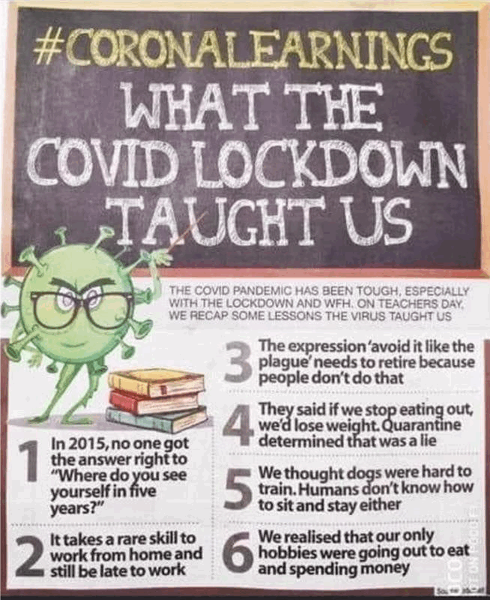

Reach out. Stay connected. Stay home. Save lives. The power of one. Be well.
Feel free to forward this on: spread the word, not the virus.
HAO
24/7

Links for Today

- Crosby, Stills and Nash: Woodstock: https://www.youtube.com/watch?v=4lx86B6a3kc
- Peter Cetera, Glory of Love: https://www.youtube.com/watch?v=1eQWdpWjXlk
- It’s a Neurological Thing: https://rdouglasfields.com/2017/09/29/music-makes-cry/
- Want a Good Book – BOOM!: https://www.amazon.com/BOOM-Boost-Our-Own-Metabolism/dp/B088B4PVZD
- Maryland Covid-19 Dashboard: https://coronavirus.maryland.gov/
- Maryland Rt: https://rt.live/?fbclid=IwAR1wdbbX1wtiPpnATDwr1fqRzgTXQZhomcO1lCk6bGrxae0ia8KUWOSa2HM#FL

