
COVID-19-79 –January 14, 2021
Dear Patients:

As a follow-up to tonight's earlier COVID information, below are links to register to be notified when appointments are ready to be scheduled for Howard County residents in Phase 1B and Phase 1C. Please read carefully to be sure you register for the proper Phase, based on your age.

New Vaccine Distribution Groups in Maryland:

- Phase 1B now includes Marylanders 75+, Residents in Assisted Living, and K-12 Educators. Here is the link to register to be notified when appointments are available to schedule for Howard County residents.
- Phase 1C now includes all Marylanders ages 65-74. Here is the link to register to be notified when appointments are available to schedule for Howard County residents.
- If you reside in a different county or state, you will need to check with the local health department.
- The vaccines are by APPOINTMENT ONLY and signups are through the County Health Department where you live. The dates for each group vary from county to county.
- Currently, distribution in Maryland is strictly through County Health Departments - private practitioners like me cannot give the vaccine.
- I will keep you up to date on local availability!

On a musical note:

Help Is On It's Way by Little River Band.

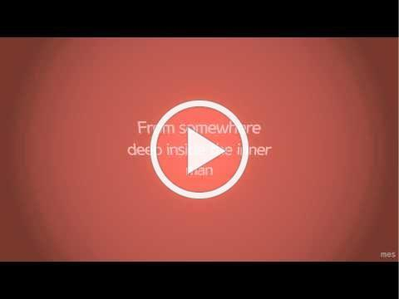

On a lighter note:



As a reminder, I am no longer sending out daily updates and instead, I'm updating you periodically as things change. Just like yesterday, face masks, social distancing, hand washing and/or sanitizer whenever you need to leave your safe zone. Stay home if you display any symptoms.

I continue to enjoy writing these updates. Initially, these were only sent to my patients, however, I have been humbled to learn that, through social media, these writings have been forwarded and re-forwarded to many. This has brought me great joy to know that this simple act of sharing facts, thoughts, opinions, and hopes have touched you in some way. Hopefully, I have been able to reassure you, maybe make you smile and laugh, soothe your worries, and comfort you. And maybe, just maybe, I have helped you to be in the moment!

Reach out. Stay connected. Stay home. Save lives. The power of one. Be well.
Feel free to forward this on: spread the word, not the virus.

HAO

Harry Oken, M.D.
Adjunct Professor of Medicine
University of Maryland, School of Medicine

Office 410-910-7500 |Fax 410-910-2310 |Cell 443-324-0823

View previous newsletters: http://harryokenmd.com/COVID-19-HOME.htm

Links for Today

- Register to be notified for Howard County appointments (75+): https://www.surveymonkey.com/r/CoVaClinic75
- Register to be notified for Howard County appointments (65-74):
https://www.surveymonkey.com/r/CoVaClinic65
- Help Is On It's Way by Little River Band:
https://www.youtube.com/watch?v=01O0D04M29o&ab_channel=MeganSmith

