
COVID-19-08 – March 20, 2020

Dear Patients,

First, we are going to be okay! (click it) (https://www.youtube.com/watch?v=5pBjopDymts)

The front page of today's Washington Post: "Fate of outbreak in hands of 328 million".

And so, if you want to help, it is all within our collective power. Check this out:

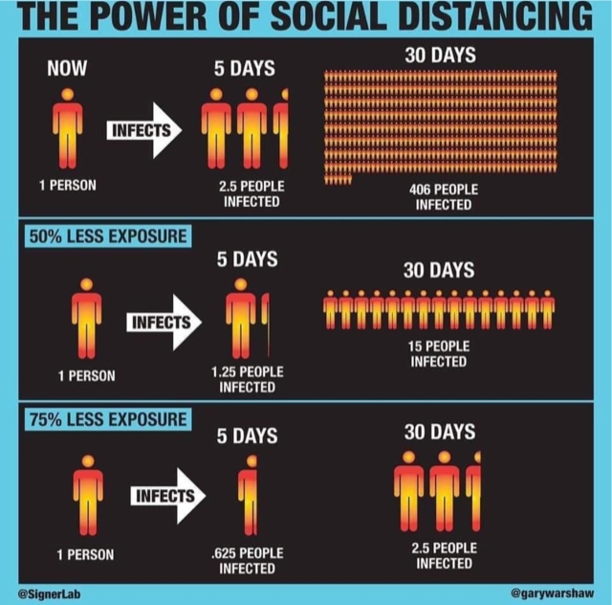

The numbers:
As of this morning, here are the numbers:

USA = 205 deaths, 14,250 positive, fatality rate 1.4%

South Korea = 94 deaths, 8,652 positive, fatality rate 1.0% (note - misquoted yesterday as 0.2%, however that was number for Germany)

Germany = 44 deaths, 16,290 positives, fatality rate 0.2%
It will take another 2-3 weeks to see the effects of our lock down. I am told that a large number of tests will be available locally very soon. As our prevalence increases, I am hopeful that we will see a trend toward a reduction in the rate of fatalities. Anthony Fauci, MD this morning said "I cannot see that all of a sudden, next week or two weeks from now it's going to be over. I don't think there's a chance of that." Further, he said he thought it will be several weeks before we have a better sense of our trajectory.  Innovation:  It's happening. Antivirals, old drugs, and new drugs, monoclonal antibodies, filters, passive use of recovered patient serum. When the chips are falling apart, that is when we find the strength to rebuild. That is who we are. | 
Houston we got a problem.. (click it)....now (we, us, Americans) will rework the problem ...and we will persevere! (https://www.youtube.com/watch?v=DAdTH5Kz6T0).

Be safe. Stay home -- HAO 24/7
For urgent matters, please call my cell. For non-urgent, please use email; due to the large number of text messages I've been receiving, it's too easy for me to miss some.

(Thanks SO)
Stay home, be well—HAO  Harry A. Oken, M.D. | Office: 410-910-7500, Fax: 410-910-2310  Cell: 443-324-0823  Adjunct Professor of Medicine  University of Maryland School of Medicine
Copy and paste to hear music
https://www.youtube.com/watch?v=DAdTH5Kz6T0&authuser=0
https://www.youtube.com/watch?v=5pBjopDymts&authuser=0

