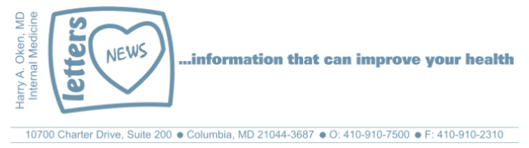
COVID-19-91 – October 21, 2021
Dear Patients:

Most people clearly remember exactly where they were on September 11, 2001, at 8:46am.

Come From Away is a Broadway musical I saw pre-Covid, and the movie is now available as a filmed version of an onstage Broadway performance on Apple TV+. I watched the movie this past weekend and remembered the impact it had on me. You may not know the plot line of this true story: on 9/11, with airspace suddenly closed, planes are diverted and grounded. In the small town of Gander in Newfoundland, with a population of 9,000 residents, they have just absorbed 28 large aircraft with 7,000 stranded airline crew members and passengers. These are people from all over the world who had been headed all over the world, but definitely not to the dark, rock island that happens to have a huge airport. The Gander residents collected clothing, blankets, and food. They've made sandwiches and hosted cookouts for 5 days. They've hosted the "plane people" in their homes.

The experience created lifelong new friendships and when the guests departed with lunch bags for their trip home, they tried to re-pay their hosts. But the people of Gander would not hear of it. Their consistent response was "you would have done the same."

"You would have done the same"
To be there for each other, a simple recipe to survive and flourish.

-
We are now 20 months into the pandemic, and we know the enemy: it is the virus. You might think, based on media reports, that this is a political issue, but it's not. The virus doesn't care about your party affiliation, it doesn't care about your race or age. According to Paul Offit, MD, an internationally recognized expert in the fields of virology and immunology who happens to be a University of Maryland School of Medicine alum (another of my shameless plugs): original mRNA vaccine you received. You may need to call around.
Based on the FDA meeting last Friday, for people over 65, get your booster.

"We have a virus, which has brought the global economy to its knees, it's caused massive unemployment, massive homelessness, food insecurity, an increase in domestic violence, an increase in child abuse, an increase in suicide - and we have our magic ticket out, a VACCINE."
Paul A. Offit, M.D.

-Those of us who have been vaccinated did so for ourselves, but also for our family, our friends, our colleagues, and everyone we come in contact with. The science is sound, the threat of a 5th surge with a new variant is ever-present. It's not a good idea to believe that doing nothing and not getting vaccinated will be okay (normalcy bias). If you are unvaccinated and over 60, and perhaps overweight or diabetic or have lung or heart issues, you are at an elevated risk if you get the virus. Further, for those over 60, a Covid infection can cause "brain fog" and can increase your risk for accelerated cognitive decline that may persist beyond recovery. If you are under 60, even a mild case of Covid can leave you with a chronic fatigue syndrome called "long hauler syndrome."

Many vaccine-resistant people who look for the truth from the internet and social media can always find nonscientific anecdotal claims (confirmation bias) that the vaccine is harmful. One consistent clear statement, based on science, that can be made is:

If you are unvaccinated and you contract Covid, you have
a greater than 10 times likelihood of complications.

-

COVID Update:

Vaccine and Booster update:
Presently, about 85% of people in Maryland have been vaccinated with at least 1 dose. All 3 vaccines are readily available at most pharmacies. Boosters should be considered for all over 65. Younger people with co-morbidities such as obesity, diabetes, lung disease, heart disease, autoimmune illness or undergoing immunotherapy for cancer, should strongly consider getting the booster as well. Initially, the recommendation was to match your booster with your initial vaccine. Now, however, it can be based on availability.

All 3 vaccines are now approved to be used as boosters and the CDC has determined that it is safe to concurrently get the booster with your flu shot.

Maryland prevalence:
Today, the prevalence has fallen further to 3.36%. The trend continues to improve. The recommendations remain the same for face masking, regular hand washing, and careful with social gatherings indoors.

Therapeutics:
Several weeks ago, information was released about a clinical trial involving the drug Molnupiravir. This drug cut hospitalization risk in half. It was so successful in the 800 patients involved in a double-blinded placebo-controlled study that the sponsor stopped this study since it was unethical to continue treatment with the placebo. The manufacturer, Merck, says that they can have 10 million doses available by the end of the year. Note that this is not a replacement for the vaccine, but it is an oral drug that may have great utility in the future. Conceptually, it can be used in a similar way that we use drugs like Oseltamivir (Tamiflu) for the flu: the sooner we know you have the infection, the sooner you start the drug, and the better the success. We still need information about its safety. Further studies will show if it has value as a drug used for post-exposure or proactively as a prophylactic medication.

Monoclonal antibody infusion info:
This continues to have great utility and I am using it on an almost weekly basis for those who are symptomatic and worsening; often these are the people who have been vaccinated but may have co-morbidities that increase their risks for complications. It is not easy to get, but we work tirelessly to get it for you if and when it is needed.

-
Come From Away: Me and The Sky: this is a rousing four-and-a-half-minute show-stopping solo that recounts the true story of Beverley Bass' historic career in the male-dominated flight industry. Bass was the captain of an American Airlines plane that landed in Gander on 9/11. Captain Bass was the first female captain with American Airlines. But she did not stop there; she continued to work her way up the ranks to become an instructor, and then made headlines around the world when she led the first all-female crew in commercial aviation history. She had a passion to become a pilot and despite many obstacles and barriers, her hard work and persistence paid off as she pursued her dream. It occurred to me that the details of her story aren't what's important; to me, it's more about pushing forward and doing what you need to do to get what you want.
-
-
On a Musical Note
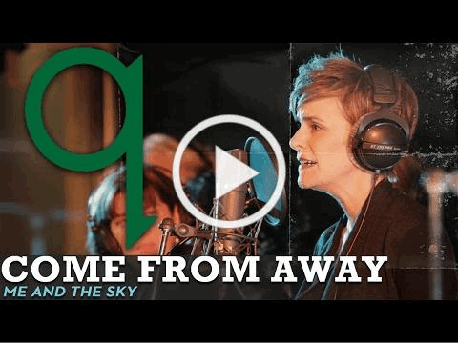

-
-
-
On a lighter note:  Have a fun and safe Halloween! | 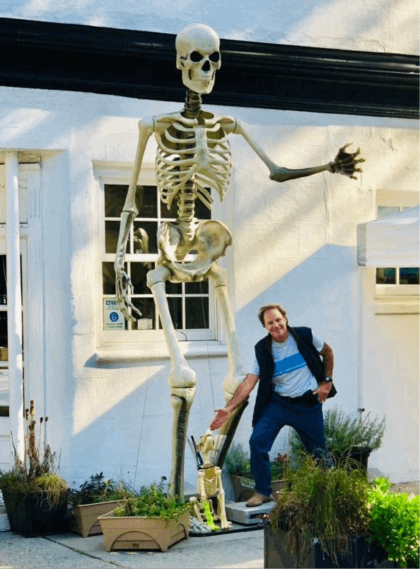

-

-
-
As a reminder, I'm no longer sending out daily updates and instead, I'm updating you periodically. I continue to enjoy writing these updates. Initially, these were only sent to my patients, however, I've been humbled to learn that, through social media, these writings have been forwarded and re-forwarded to many. This has brought me great joy to know that this simple act of sharing facts, thoughts, opinions, and hopes have touched you in some way. Hopefully I've been able to reassure you, maybe make you smile and laugh, soothe your worries, and comfort you. And maybe, just maybe, I've helped you to be in the moment!

Reach out. Stay connected. Stay home. Save lives. The power of one. Be well.
Feel free to forward this on, spread the word, not the virus.
HAO

HAO

Harry Oken, M.D.
Adjunct Professor of Medicine
University of Maryland, School of Medicine
Office 410-910-7500 |Fax 410-910-2310 |Cell 443-324-0823

View previous newsletters: http://harryokenmd.com/COVID-19-HOME.htm

Links for today

- Come From Away - a Broadway musical:
https://tv.apple.com/us/movie/come-from-away/umc.cmc.262n0v53nmotkz7ulzuuco7rq
- Come From Away - Me and The Sky:
https://www.youtube.com/watch?v=vQVrbzBv-AU&ab_channel=qoncbc
- Immunodeficiency as defined by the CDC:

