
COVID-19-108 November 23, 2022
Dear Patients:

Neil Diamond's Sweet Caroline is an iconic song. I think that for many listeners, it strikes a chord about relationships. The song has become a staple played during many sporting events, and you may recall that it was played to help uplift the city of Boston in 2013 after the Boston Marathon bombing. For over two decades, it has been the official chant of the Boston Red Sox.

When Diamond wrote the song, he said he was trying to express how he felt about his second wife, Marcia, who he later divorced in 1995. Marcia, however, did not fit the 3-syllable name to work with the melody, but Caroline fit the bill. There is also another version of the origination of the name. Diamond, as a "young, broke songwriter" in the 60's, saw a photo of Caroline Kennedy in a magazine. "It was a picture of a little girl dressed to the nines in her riding gear next to her pony. It was such an innocent, wonderful picture. I immediately felt there was a song in there." The bottom line is the listener decides on the song's significance

Sweet Caroline is an uplifting and joyful musical piece about how relationships make people feel. And for my holiday 3-minute talk that I give at our Thanksgiving dinner, I thought I would "unpack the song."

"Where it began": If you are a parent, you know exactly "where it began" when your life changed. For mothers, as soon as they learn they were expecting, and fathers, maybe then, but certainly the very moment the newest family member was born. From that moment on, this little person just changed your life and forevermore you are just so grateful. But this feeling is not just about children; it can be "where it began" with your spouse, your sibs, your family, and your friends.

"Hands, touching hands, reaching out, touching me, touching you": Ah, yes, the power of touch. A baby is born, and its life begins with touch, skin to skin. It feels good for everyone who holds the baby, and for the baby, of course, as well. Touching causes a massive release of "feel good" hormones, oxytocin, and then other hormones that seal the deal; incredible how that works. A vibrant hug, a meaningful handshake, and a kiss on the cheek are sustaining, connecting, and so important.

"Sweet Caroline, good times never seemed so good": This Thanksgiving, I celebrate and am grateful for the gift of relationships. For me, and I hope for you as well, they are cherished. And if you are in conflict with someone you care about, take the higher road, think about "where it began" and reach out and "touch" them in some way. I think we all want the same thing - "good times."

-


-

-
On a musical note: Sweet Caroline by Neil Diamond



-

Wishing you the best:

Thanksgiving this year took an unexpected turn when I tested positive for Covid on Monday. So, I'll be spending the week in isolation with my dog, away from my family. And I'll be grateful for FaceTime. ﻿

Below are photos of me with both of my grandsons shortly after each of them was born - "where it began."

-
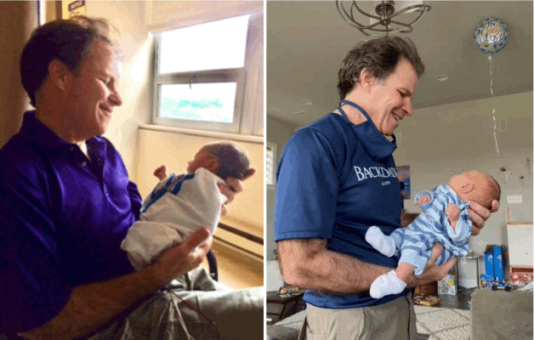

-

As a reminder, I'm no longer sending out daily updates and instead, I'm updating you periodically. I continue to enjoy writing these updates. Initially, these were only sent to my patients, however, I've been humbled to learn that, through social media, these writings have been forwarded and re-forwarded to many. This has brought me great joy to know that this simple act of sharing facts, thoughts, opinions, and hopes has touched you in some way. Hopefully I've been able to reassure you, maybe make you smile and laugh, soothe your worries, and comfort you. And maybe, just maybe, I've helped you to be in the moment!
Reach out. Stay connected. Stay home. Save lives. The power of one. Be well.
Feel free to forward this on, spread the word, not the virus.
HAO
Harry Oken, M.D., Adjunct Professor of Medicine, University of Maryland, School of Medicine
Office 410-910-7500 |Fax 410-910-2310 |Cell 443-324-0823

View previous newsletters: http://harryokenmd.com/COVID-19-HOME.htm

Links for today

- Neil Diamond's Sweet Caroline:
https://www.youtube.com/watch?v=0iN-hemcKc8&ab_channel=YoungPilgrimMusic

