
COVID-19-109 December 23, 2022
Dear Patients:

As we slide into the holidays and our lives slow down a bit, I thought I would send you this; I've been working on it for a while. It's better if you get the music going then continue reading.
--------------------------------------------------------------------------------------------------------------------------------------------

--------------------------------------------------------------------------------------------------------------------------------------------

When I was a kid, I had trouble falling asleep, so I devised a bedtime game. I pretended I was on a rocket ship. The blast-off pad was my home in Pikesville, a suburb of Baltimore. My rocket was equipped with a special rear-view screen so I could watch as I was jettisoning away from earth. On takeoff, I could see leaving my home, city, country, and earth, then the solar system, then our galaxy and then other galaxies. Often, I fell asleep before reaching "the very end" of the universe, but sometimes I did reach the end, the very edge of the universe. And in the end, what was there? Intensely bright white light. Just brilliant white light. Black and white are not colors; white light illuminates and it's good to be enlightened, while black is the absence of visible light. Going dark can feel bad.

-
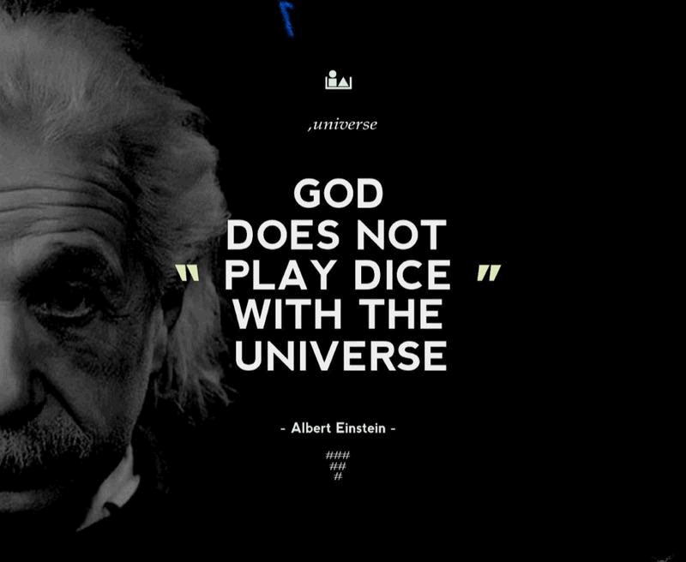

-
What is this life all about? We are a speck of existence in the universe. But something must hold us together and make things relevant. Are we part of something bigger? Are there multiple universes? And if there are, what is beyond that?

There are times, for a fleeting microsecond, that I think I am close to understanding how everything fits together; it tends to happen at joyful times, it's odd and it's very evanescent. Einstein spent the last 30 years of his life working to understand this. He tried to construct the Unified Field Theory. He got stuck because he could not accept the randomness proposed by his friend, Niels Bohr, who conceived the Quantum Theory. So, yes, Einstein was human and experienced the backfire effect. He dug his heels in and focused on finding forces that explained how it all works. Einstein died at 75 of a ruptured aortic aneurysm, with math notes and a pencil on his nightstand.

-
I believe there is an interconnectedness. I think we all feel it at times; we can't measure it or see it. Eventually, there will be a tool to be able to detect it. Remember, we couldn't see bacteria until we created the microscope; it was hard to believe in viruses until we invented the electron microscope. Yet, I think we can feel interconnectedness. It especially happens to me when I am with the people I love. I also feel it when I help to heal. There are moments when I know something I discovered, said, or did, made a difference. Those moments connect me and recharge me. I am sure other people experience this as well. Our connection with each other is an excellent tonic. Those moments may be with family, friends or at work. You might be an artist or a scientist, a dad, or a mom, or maybe you feel it when you "hit the wall" running or during yoga or prayer. Keep looking for it and feel it, and once you feel it, chase it again.

-

Want to learn more about vaccines, including COVID?

Listen to my podcast, ‘Finding your Wellness’, sponsored by the Columbia Association. This month's guest is Paul Offit, M.D.; Paul is a University of Maryland alumnus and world-famous vaccinologist. Coincidentally, Paul also grew up in Baltimore and we recently figured out that I sat next to his sister in homeroom from 7th through 12th grade. There, you see, interconnectedness!

Click here: The Importance of Vaccines

-


-

As a reminder, I'm no longer sending out daily updates and instead, I'm updating you periodically. I continue to enjoy writing these updates. Initially, these were only sent to my patients, however, I've been humbled to learn that, through social media, these writings have been forwarded and re-forwarded to many. This has brought me great joy to know that this simple act of sharing facts, thoughts, opinions, and hopes has touched you in some way. Hopefully I've been able to reassure you, maybe make you smile and laugh, soothe your worries, and comfort you. And maybe, just maybe, I've helped you to be in the moment!
Reach out. Stay connected. Stay home. Save lives. The power of one. Be well.
Feel free to forward this on, spread the word, not the virus.
HAO
Harry Oken, M.D., Adjunct Professor of Medicine, University of Maryland, School of Medicine
Office 410-910-7500 |Fax 410-910-2310 |Cell 443-324-0823

View previous newsletters: http://harryokenmd.com/COVID-19-HOME.htm

Links for today

- The Importance of Vaccines: https://dragondigitalradio.podbean.com/e/the-importance-of-vaccines/
- A Million Dreams: https://www.youtube.com/watch?v=xeQnXe6DLtM&list=RDQgaTQ5-XfMM&index=4

