
COVID-19-121, October 9, 2024
Dear Patients:

The first episode of St. Elsewhere was in the fall of 1982; the storyline reeled in many people, especially those of us in medical training. The first years of the show talked a lot about medical residency and training and the trials and tribulations that physicians experience as they learn about life in medicine and the realities of the human condition. Whenever I hear the Dave Grusin Theme Song from St. Elsewhere, it takes me back to my years of training. Check out the song - it has always inspired me. The music has a tempo that inspires optimism, even in the face of near pandemonium. St. Elsewhere spoke to me. I looked forward to every episode, identifying with many of the daily issues the doctors, nurses, and administrators had to deal with. I am fortunate to be in a profession that has challenged me daily to make a difference.

-------------------------------------------------------------------------------------------------------------------------------------
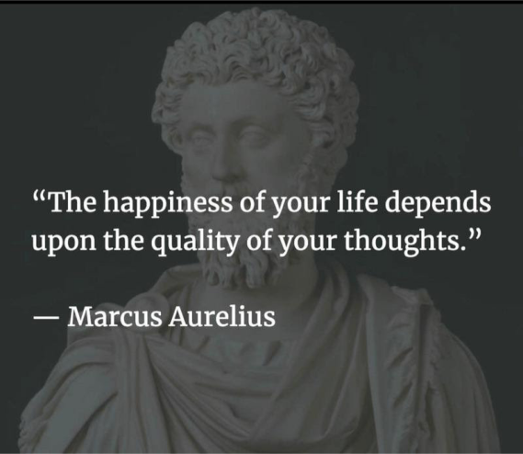
-------------------------------------------------------------------------------------------------------------------------------------

Two Upcoming Columbia Association Events:

On Saturday, October 19 at 9:00 am, I will be leading the monthly Walk with a Doc. I'll send out a reminder and details several days prior. Thank you to my friend and colleague, Dr. Dean Glaros, for leading the September walk. Mark your calendars for Wednesday, October 23 at 6:00 pm, A Way to Wellness: Finding Your Best Self, at the James Rouse Theater at Wilde Lake High School. I will be introducing our panel of local physicians for a question-and-answer session. Local community health groups will have an expo set up along the high school's Main Street and there will be light fare compliments of Mission BBQ. Stay tuned for further information.
-------------------------------------------------------------------------------------------------------------------------------------
On a musical note:

The opening theme song to St. Elsewhere was composed by the famed jazz musician and composer, Dave Grusin. Grusin produced his first single in 1962 and his first film score in 1967. He has a filmography of approximately 100 titles.  Listen here. | 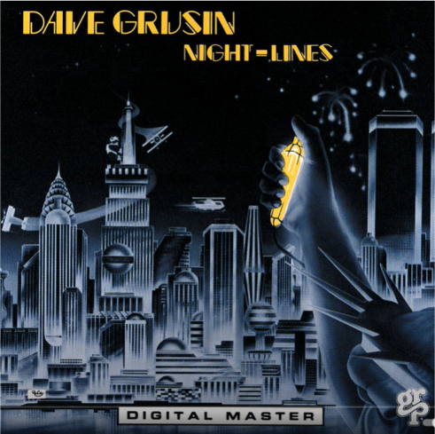
-------------------------------------------------------------------------------------------------------------------------------------

-------------------------------------------------------------------------------------------------------------------------------------

As a reminder, I no longer send out daily updates and instead, I'm updating you periodically. I continue to enjoy writing these updates. Initially, these were only sent to my patients, however, I've been humbled to learn that, through social media, these writings have been forwarded and re-forwarded to many. This has brought me great joy to know that this simple act of sharing facts, thoughts, opinions, and hopes have touched you in some way. Hopefully I've been able to reassure you, maybe make you smile and laugh, soothe your worries, and comfort you. And maybe, just maybe, I've helped you to be in the moment!

HAO

Harry Oken MD
Former Chairman of Medicine 1994-2008
Howard County General Hospital

View previous newsletters: http://harryokenmd.com/COVID-19-HOME.htm

LINKS FOR TODAY

- Dave Grusin Theme Song from St. Elsewhere
https://www.youtube.com/watch?v=2ivA69Nrf0c&ab_channel=DaveGrusin-Topic

- A Way to Wellness: Becoming Your Best Self
https://columbiaassociation.org/events/calendar/#event=77703042;instance=20241023180000?popup=1&lang=en-US
- St. Elsewhere
https://www.youtube.com/watch?v=2ivA69Nrf0c&ab_channel=DaveGrusin-Topic

